**Artificial Intelligence Lab**

**LAB 3 – Constraint Satisfaction Problem**

**Aditya Kumar**

**RA1911030010100**

**O2 Section**

**Date – 28/1/22**

**Problem Statement :**

Solve the problem

S E N D

+ M O R E

-------------

M O N E Y

**Algorithm:**

1. Put the letters as equality contraints

Expression1 = 1000*s +100*e +10*n + d

Expression2 = 1000*m + 100*o +20*r + e

Expression3= 10000*m + 1000*o +100*n + 10*e +y

IF(expression3==expression1+expression2)

Print values of s,e,n,d,m,o,r,y

1. Perform permutations on each letter where they can have values ranging from 0-9

**Code:**

def consat():

consats = list()

for s in range(9, -1, -1):

for e in range(9, -1, -1):

for n in range(9, -1, -1):

for d in range(9, -1, -1):

for m in range(9, 0, -1):

for o in range(9, -1, -1):

for r in range(9, -1, -1):

for y in range(9, -1, -1):

if len(set([s, e, n, d, m, o, r, y])) == 8:

send = 1000 * s + 100 * e + 10 * n + d

more = 1000 * m + 100 * o + 10 * r + e

money = 10000 * m + 1000 * o + 100 * n + 10 * e + y

if send + more == money:

consats.append((send, more, money))

print("Problem has been solved")

return consats

print(consat())

**Output:**

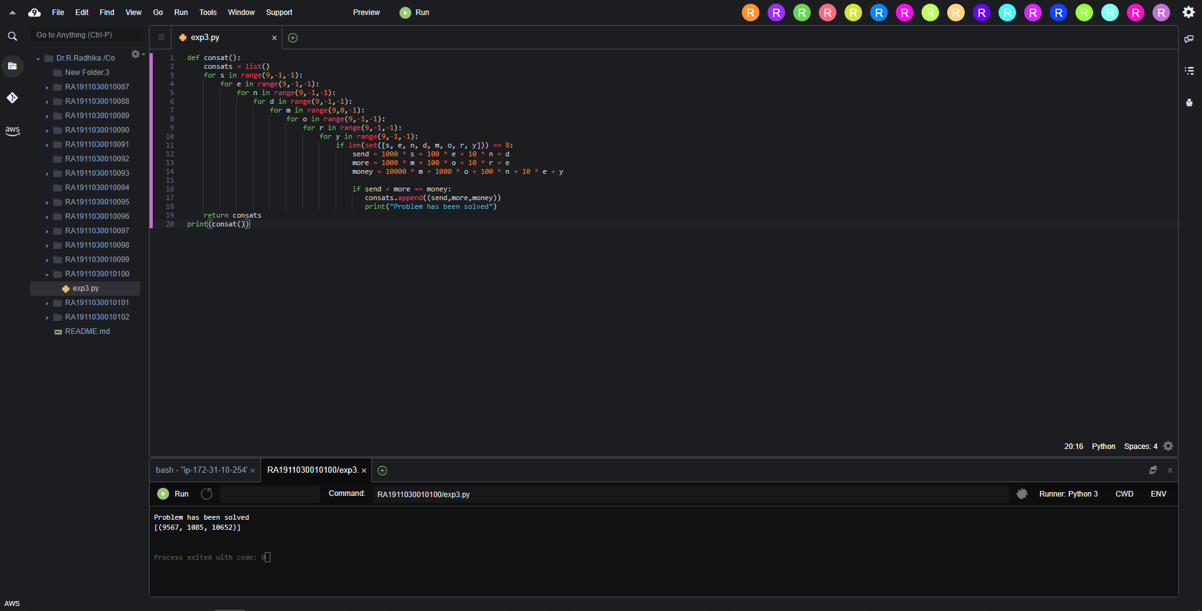

Result:

Hence the constraints were satisfied and the problem was solved.